Stan Lee
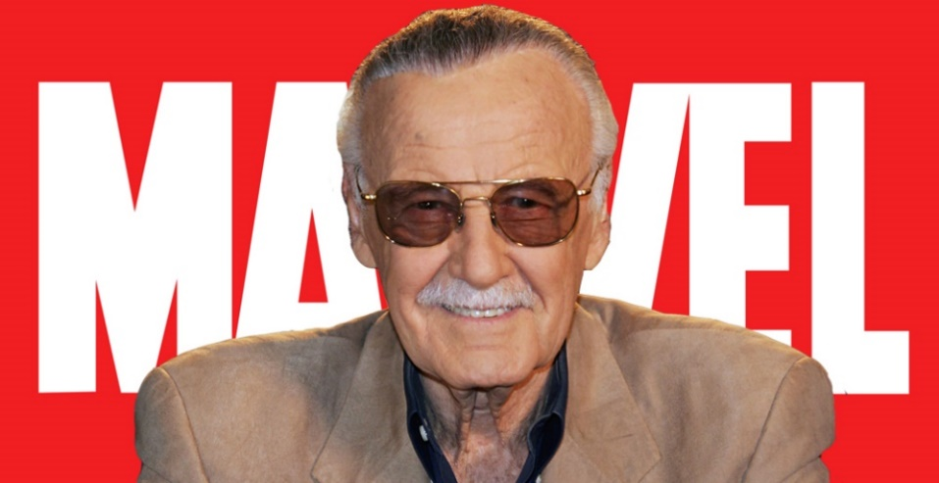
Stan Lee was an American screenwriter, producer of comics and movies. He was a long-time member of the board of Marvel Comics. Stan Lee was cooperaiting with famous people like Jack Kirby, Steav Ditko and with his brother Larry Lieber. He created with them a lot of MCU characters like: Spider Man, Iron Man, Hulk, Doctor Strange, Fantastick Four, Derdevil, Black Panther, Thor and X-Mans.

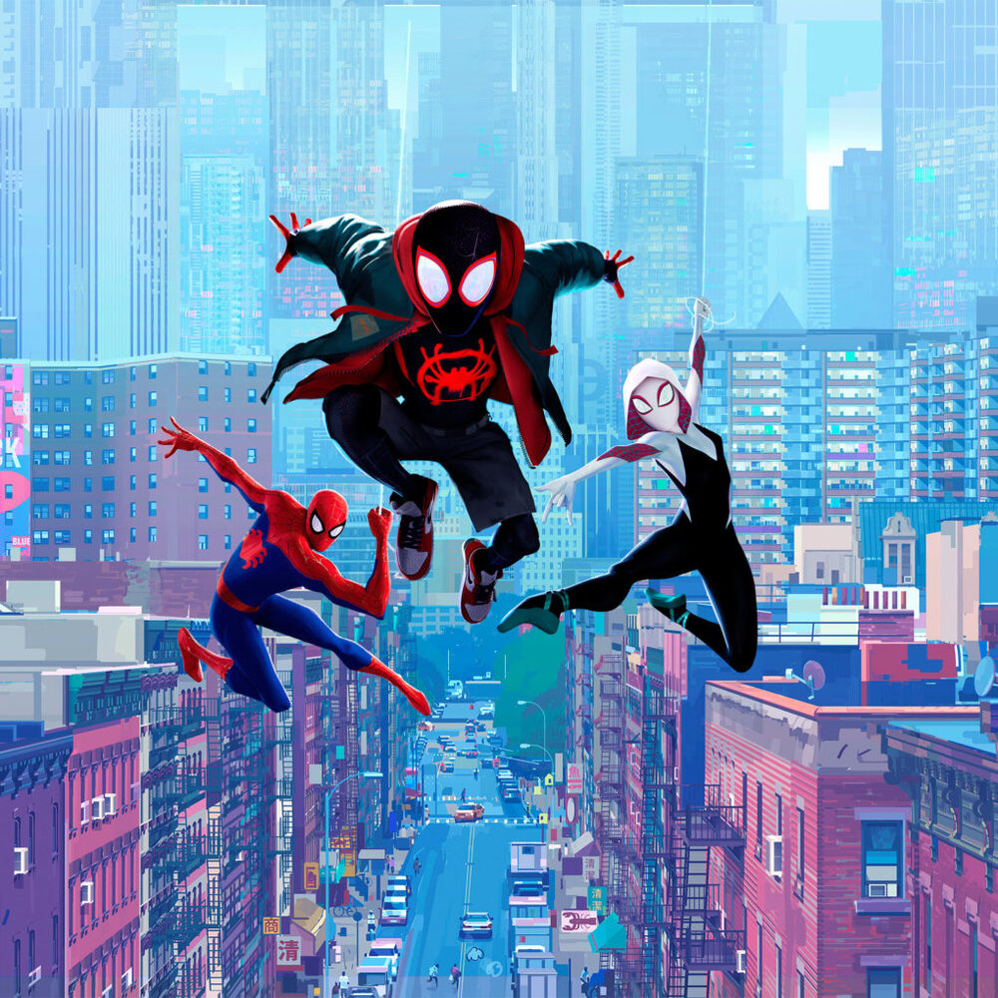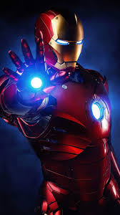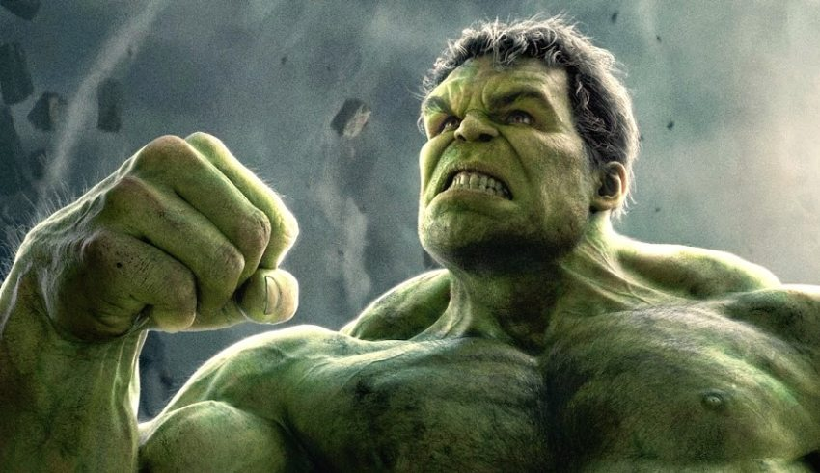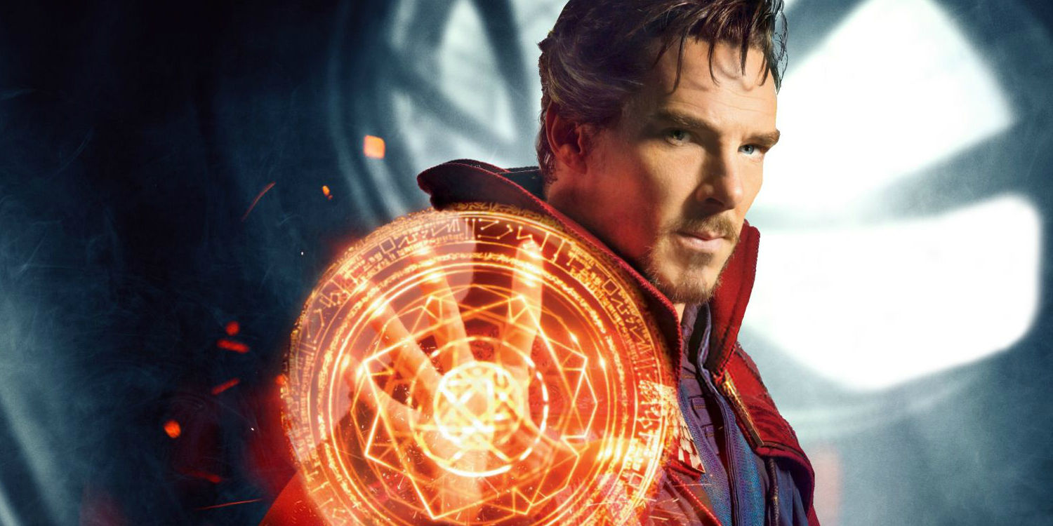

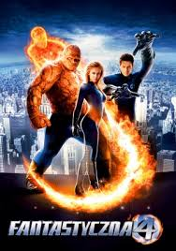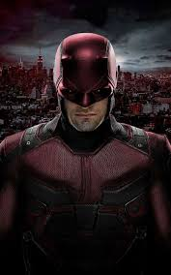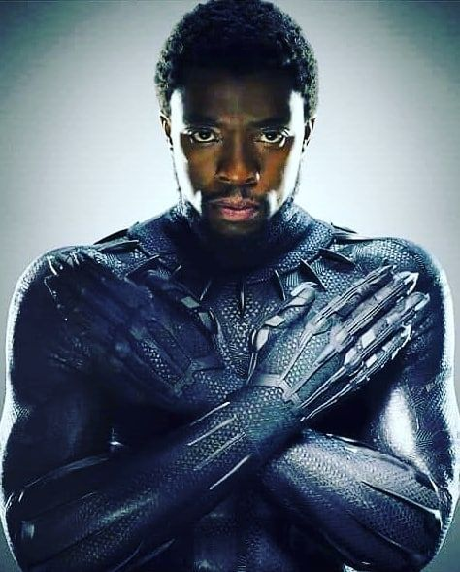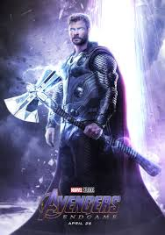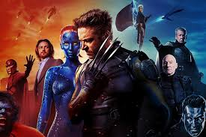
Stan Lee helped Marvel a lot and now Marvel is one of the best movie and comics studios in the world. Stan Lee in 2008 was awarded a National Art Medal. Unfortunately Stan Lee died two yers ago, he was almost 96 yers old.
In my opinion, Stan Lee was one of the greatest people of the English-speaking countries because he helped strongly to the developmend of superhero films and, most importantly, he is icon of enormous imagination.

