LEWIS HAMILTON
Lewis Hamilton is a British racing driver currently competing in Formula One for the Mercedes-AMG Petronas Formula One Team. He is the most successful driver in the history of the sport. He broke Michael Schumacher’s records (Lewis Hamilton has 94 wins, 97 pole positions, 163 podium finishes, 227 points finishes, 3738 career points and 413 points in a season). In Turkey (15.11) he became the seventh world champion. Hamilton is widely regarded as one of the greatest drivers in the history of the sport.
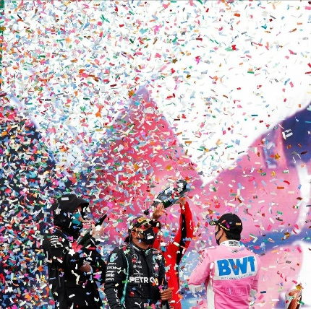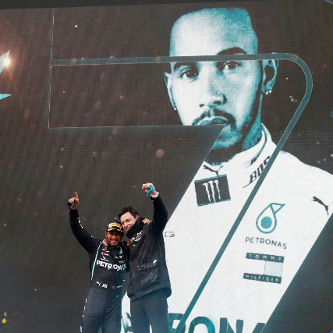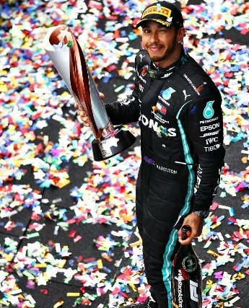
Lewis Hamilton started his career in 2007 by joining McLaren making the first and only black drive in race sport. After six years in McLaren, he signed with Mercedes in 2013.
He was appointed an MBE after he won his first title in 2008, which was odd because previously all World Champions were OBEs.
Why Lewis Hamilton? Because he inspiring me as the best sportsman in the world and because of that I know I can be also the best. I will always support him and be his the biggest fan. Thanks to him, I achieved what I could achieve and I have dreams that will come true in the near future. I hope to meet him next year.

