Freddie Mercury
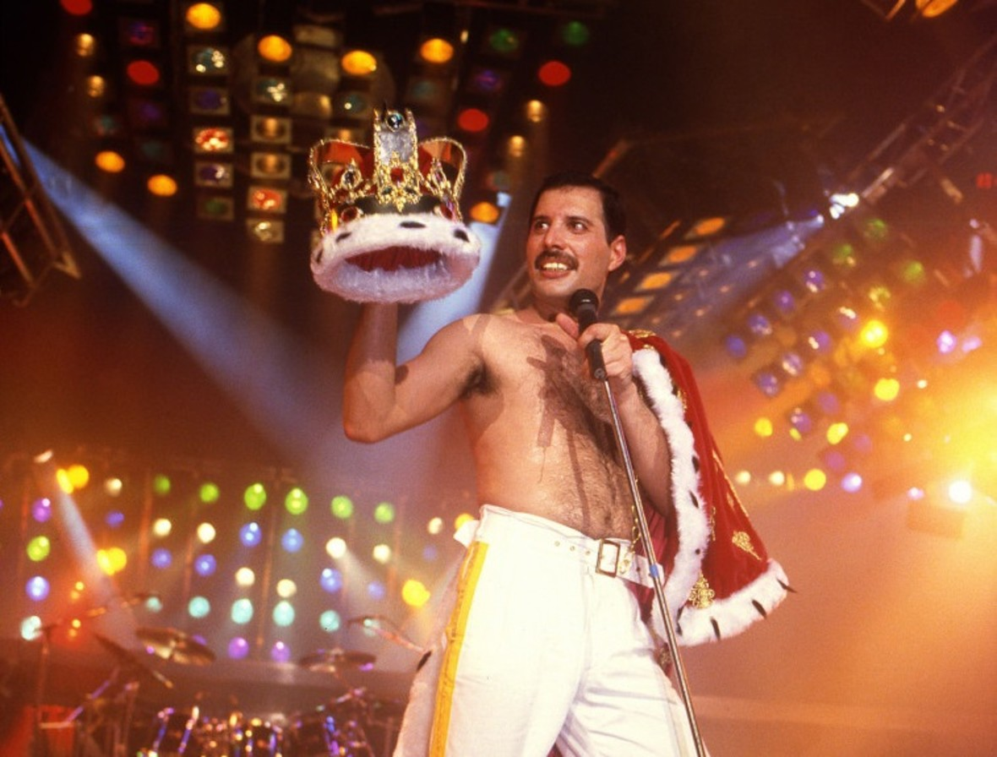

Freddie Mercury, was born 5 September 1946, in Stone Town in Sultanate of Zanzibar.
He was Regarded as one of the greatest singers in the history of rock music, he was known for his flamboyant stage persona and four-octave vocal range.
Mercury spent most of his childhood in India where he began taking piano lessons at the age of seven. In 1954, at the age of eight, Mercury was sent to study at St. Peter's School, a British-style boarding school for boys, in Panchagani near Bombay. 12, When he was 12, he formed a school band, named „The Hectics”. While studying at St. Peter's he started to call himself „Freddie”.
When Freddie was 20 he and his family moved to the England. Mercury studied graphic art and design at Ealing Art College, graduating with a diploma in 1969.
His first job was selling second-hand clothes in Kensington Market in London, where he met Roger Taylor, who played drums in Queen. Mercury also held a job as a baggage handler at Heathrow Airport. Friends from the time remember him as a quiet and shy young man with a great interest in music. In 1969, he joined band Ibex, which played "very Hendrix-style, heavy blues".

Beginnngs of Queen

In April 1970, Mercury teamed up with guitarist Brian May and drummer Roger Taylor, to become lead singer of their band called „Smile”. In 1971 They meet John Deacon and create new band with him as bassist, Freddie chose the name „Queen”.
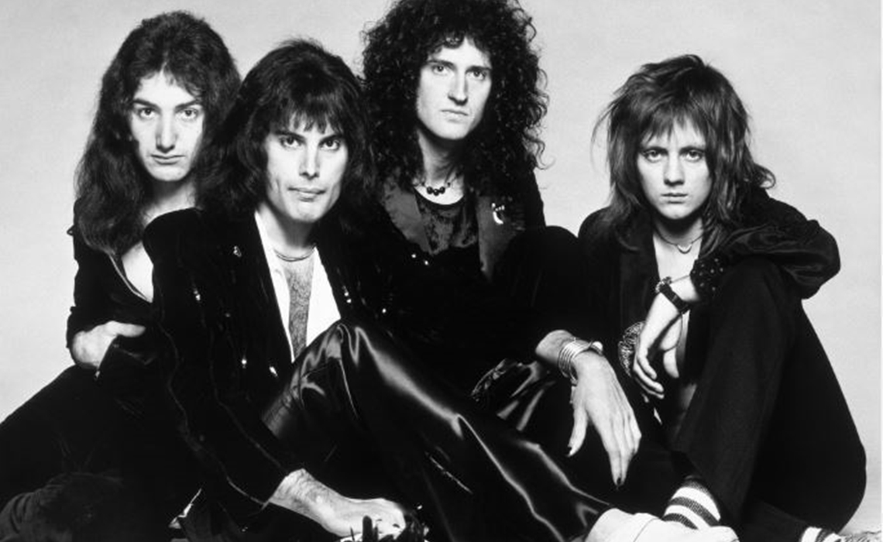

Queen became one of the greatests bands i music history. They have many albums like „A Night at the Opera”, „A Kind of Magic” or „Innuendo”.
Mercury has tho albums outside the Queen, „Mr. Bad Guy” with debuted in the top ten UK Album Charts, and „Barcelona”.
Barcelona was recorded with Spanish soprano vocalist Montserrat Caballe, it combines elements of popular music and opera.

In 1985 Freddie return to Queen, they decided to play on Live Aid – concert organised to raise funds for relief of the Ethiopian famine. It was one of their greatests shows.
Before Live Aid Freddie told his friends that he has AIDS and he will die soon, they decided that they will spend as much time as posiible on making new music.
Queen released three more albums before Mercury died.

Death

Freddie Mercury died in the evenig of 24 November 1991, at age 45 at his home in Kenisington.
After he died almost all of his money went to The Mercury Phoenix Trust – his chairity organisation that fights HIV/AIDS.

Tribute Concert

In April 1992, the remaining members of Queen founded and organised The Freddie Mercury Tribute Concert for AIDS Awareness, to celebrate the life and legacy of Mercury and raise money for AIDS research, which took place on 20 April 1992, on Wembley Stadium for an audience of 72,000, featured a wide variety of guests including Robert Plant (of Led Zeppelin), Roger Daltrey (of the Who), Extreme, Elton John, Metallica, David Bowie, Annie Lenox, Tony Lommi (of Black Sabbath0, Guns N’ Roses, Elizabeth Taylor, George Michael, Def Leppard, Seal, Liza Minnelli, and U2.
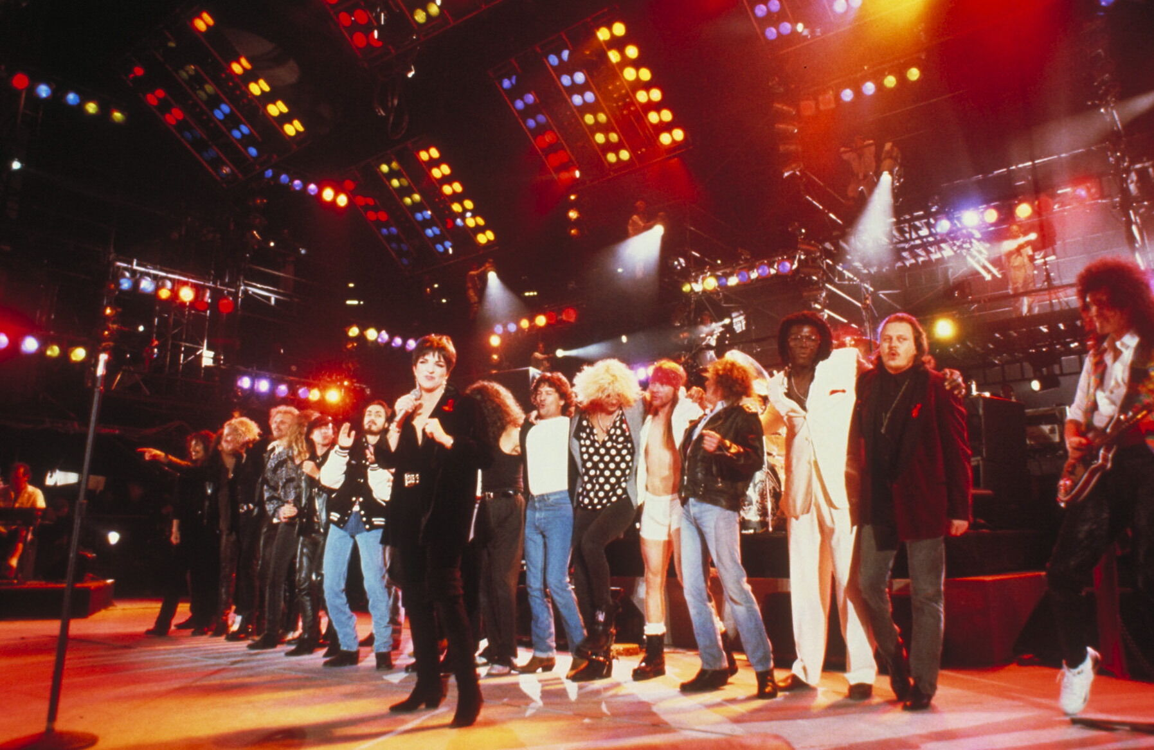
Freddie Mercury Tribute Concert

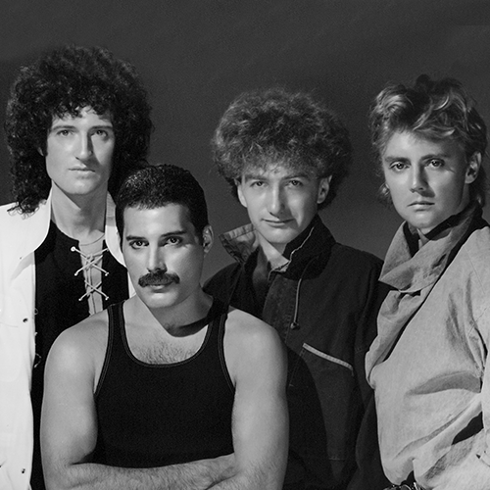
Queeen

